**Introduction**

Every organization's risk management plan must include disaster recovery. Businesses and institutions are always at risk from a variety of natural and man-made calamities that can impair their operations and threaten their continuity in an increasingly linked and data-driven world. Disaster recovery planning and execution have become crucial in order to meet this challenge. This procedure is a methodical approach to guarantee the prompt post-disaster restoration of vital systems, information, and operations. In this situation, the goal of disaster recovery activities is to reduce downtime, safeguard important assets, and eventually secure a company's capacity to provide services and carry out its mission even in the face of difficulty. l

**Objective**

The goal of disaster recovery is to enable a quick and effective reaction to interruptions while safeguarding an organization's vital data, assets, and activities in today's fast-paced and interconnected world. Disaster recovery helps organizations retain continuity by reducing downtime, ensuring that crucial functions are quickly restored, protecting data, and promoting resilience in the face of adversity. Disaster recovery plans thus contribute to a larger risk management framework, which is essential in today's uncertain and dynamic world. They help safeguard an organization's reputation and financial stability.

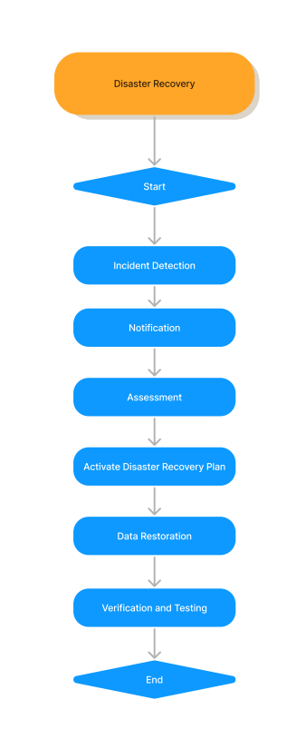 sd DLW **Flowchart**

1. **Start**: This is the initiation of the disaster recovery process. It’s the point where the need for disaster recovery is recognized, and the decision to activate the disaster recovery plan is made.
2. **Incident Detection**: This step involves identifying and acknowledging that a disaster has occurred. It’s crucial to have monitoring systems in place to detect incidents promptly and accurately.
3. **Notification**: Once an incident is detected, relevant stakeholders are informed. This could include IT staff, management, and employees. Clear communication channels need to be established for effective notification.
4. **Assessment**: In this step, the impact of the incident is evaluated. This includes understanding the extent of the damage, potential risks, and deciding on the best course of action.
5. **Activate Disaster Recovery Plan**: Based on the assessment, the disaster recovery plan is activated. This plan should have been prepared in advance and include detailed steps on how to respond to different types of incidents.
6. **Data Restoration**: One of the most critical steps in disaster recovery is restoring lost data from backups. The goal is to minimize data loss and restore systems to their pre-disaster state as quickly as possible.
7. **Verification and Testing**: After data restoration, it’s important to verify that systems are functioning correctly. This could involve running tests, checking data integrity, and ensuring that all systems are operational.
8. **End**: This signifies the conclusion of the disaster recovery process. After all systems are restored and verified, normal operations can resume.